Hands-On Lab
Lab Manual
Install Java Development Kit and Tomcat

Contents
` Install Java Development Kit and Tomcat i
Lab 01: Install Java Development Kit and Tomcat 3
Lab Objective 3
Exercise 1 – Install Java Development Kit 1.6 3
Task 1 – Run the JDK setup 3
1. Execute the JDK setup. 3
2. Deselect unnecessary features. 3
3. After the installer finished, click on Finish button. 4
Task 2 – Set environment variable JAVA_HOME 4
1. Set variable environment JAVA_HOME by value “C:\Program Files\Java\jdk1.6.0_04” 4
2. Run command “java –version” to check whether the java run time is available. 5
Exercise 2 – Run Tomcat from portable package 5
Task 1 – Extract the tomcat package 5
1. Extract the tomcat package apache-tomcat-x.y.z.zip (or apache-tomcat-x.y.z.tar.gz) 5
2. Execute batch file “startup.bat” in $TOMCAT_HOME\bin to start the Tomcat. 5
3. Using browser to open URL http://localhost:8080 5
4. Execute “shutdown.bat” in $TOMCAT_HOME\bin to stop the Tomcat. 6
Task 2 – Add user admin to Tomcat 6
1. Edit $TOMCAT_HOME\conf\tomcat-users.xml. For Tomcat 7, add 2 new below bold lines within tag “<tomcat-users>”: 6
2. Restart Tomcat by execute “shutdown.bat” and “startup.bat” 6

Lab 01: Install Java Development Kit and Tomcat
Estimated time to complete this lab: 10 minutes

Lab Objective
The objective of this lab is to introduce you how to install Java Development Kit and Apache Tomcat.
- Run the JDK installer.
- Setup environment variable JAVA_HOME.
- Run the apache tomcat package.

Note: You must have administrative privileges to install the JDK.

Exercise 1 – Install Java Development Kit 1.6

In this exercise you will install the JDK. The lab uses JDK 1.6.0_04 ().

Task 1 – Run the JDK setup

  - Execute the JDK setup.
Click Setup to continue.
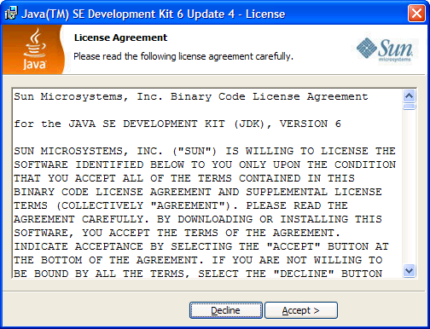

  - Deselect unnecessary features.
You can don’t install unnecessary features such as Java DB. Click on Next to continue.
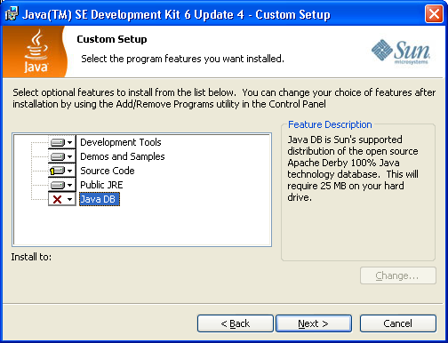

  - After the installer finished, click on Finish button.
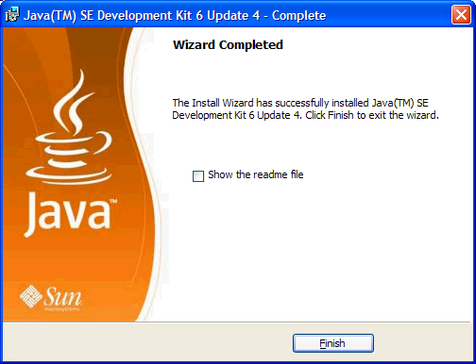

Task 2 – Set environment variable JAVA_HOME

This exercise set the path for environment JAVA_HOME. It's used by Tomcat and many other Java programs.

  - Set variable environment JAVA_HOME by value “C:\Program Files\Java\jdk1.6.0_04”
: Click on Start → choose “Control Panel” → choose “System”. In the “System Properties” dialog, select tab “Advanced” → click on button “Environment Variable”. In the section “System variable”, click on “New” button”, input:
Variable name: JAVA_HOME
Variable value: C:\Program Files\Java\jdk1.6.0_04
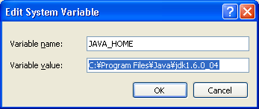
  - Run command “java –version” to check whether the java run time is available.
: Click on Start → choose “Run”, input command “cmd” (without double quotes). In window “Command Prompt”, run command “java –version”, the output is as below:
java version "1.6.0_04"
Java(TM) SE Runtime Environment (build 1.6.0_04-b12)
Java HotSpot(TM) Client VM (build 10.0-b19, mixed mode, sharing)

Exercise 2 – Run Tomcat from portable package

This exercise helps you extract and executes the apache-tomcat package ().

Task 1 – Extract the tomcat package
  - Extract the tomcat package apache-tomcat-x.y.z.zip (or apache-tomcat-x.y.z.tar.gz)
You should use a folder jPackages (such as D:\jPackages) to contain portable Java Packages.
After extract the tomcat package into the folder D:\jPackages, the home directory of Tomcat is “D:\jPackages\apache-tomcat-7.0.14”. It is abbreviated to $TOMCAT_HOME.
  - Execute batch file “startup.bat” in $TOMCAT_HOME\bin to start the Tomcat.
The console output is as below.
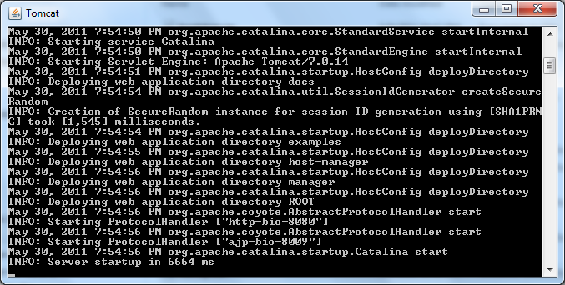

  - Using browser to open URL http://localhost:8080
The home page of Tomcat is as below:
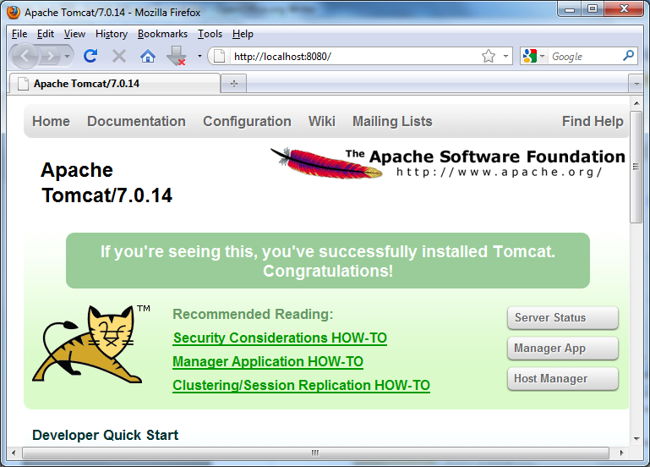
  - Execute “shutdown.bat” in $TOMCAT_HOME\bin to stop the Tomcat.

Task 2 – Add user admin to Tomcat

  - Edit $TOMCAT_HOME\conf\tomcat-users.xml. For Tomcat 7, add 2 new below bold lines within tag “<tomcat-users>”:
...
<tomcat-users>
<role rolename="manager-gui, admin-gui"/>
<user username="admin" password="admin" roles="manager-gui, admin-gui"/>
</tomcat-users>

  - Restart Tomcat by execute “shutdown.bat” and “startup.bat”
Logon by account admin/admin

Download the latest version of JDK at http://java.sun.com
Download the latest version of JDK at http://apache-tomcat.apache.org

